**EXPERIMENT 10**

**AIM: Write a program “Hello World” using http module of Node js. Demonstrate REPL in Node.js**

**CODE:**

***npm init -y*:** Initialize Node.js project by creating a package.json file

**App.js:**

const http = require('http');

// Create the HTTP server

const server = http.createServer((req, res) => {

  // Set the response header and status code

  res.writeHead(200, { 'Content-Type': 'text/plain' });

  // Send the response body

  res.end('Hello, World!\n');

});

// Server listens on port 3000

server.listen(3000, () => {

  console.log('Server running at http://localhost:3000/');

});

**OUTPUT:**

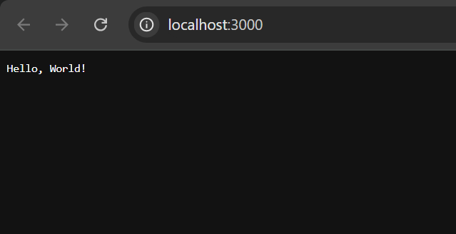

**CONCLUSION: Hence, we have successfully implemented a program “Hello World” using http module of Node js. Demonstrate REPL in Node.js.**